CSC 4350: Software Engineering

Fall 2016 Semester

October 16, 2016

Document #4 – Object Design

Team Name: Real Team 6

Application Name: Booki

Team 6 Members:

Anthony Jones

McKenzie Rochester

Daniel Campbell

Jeff Sikala

Jordan Smith

Table of Contents

Requirements Trace Matrix (RTM)3

Function Cost Analysis (FCP)4

Design of Objects5

Work Share Document (WSD)6

Gantt Chart7

Dictionary8

Rational of Objects9

**Requirements Trace Matrix (RTM)**

|  |  |  |  |
| --- | --- | --- | --- |
| Entry Number | Paragraph Number | RTM Entry | Type |
| 1 | 2.1 | User is prompted to login using email and password | SW |
| 2 | 2.2 | If the User does not have an account, then the user will be prompted to create a new account. | SW |
| 3 | 2.3 | The web application will redirect a new user to an account registration page when they are directed to make one. | SW |
| 4 | 2.4 | The user will be taken to their timeline page where they can view book postings, transactions and messages. | SW |
| 5 | 3.1 | Users are about to create book postings when they are ready to sell their items. | SW |
| 6 | 3.2 | Book Transactions will send a notification and email to both the potential seller and buyer when a transaction is complete. | SW |
| 7 | 3.3 | The application will send a notification and email to the potential seller and buyer when a transaction is complete. | SW |
| 8 | 3.4 | The application will allow users to update their account information via an update page. | SW |
| 9 | 4.1 | The application will ask the users to update the status of the transaction one hour after completion. | SW |
| 10 | 4.2 | A survey will be initialized to ask the buyer how satisfied they were with the seller. | SW |
| 11 | 4.3 | If the survey is not complete, then the system will not allow another transaction until it has been completed. | DR, SW |
| 12 | 4.4 | A search menu will be used to find books by specific categories. The search option will be able to search by book title, ISBN, course, and major. | SW |
| 13 | 4.5 | The application will run on a Linux server. | HW |
| 14 | 4.6 | The application will utilize SQLite as its database system. | HW, SW |

**FCP (Function Cost Analysis)**

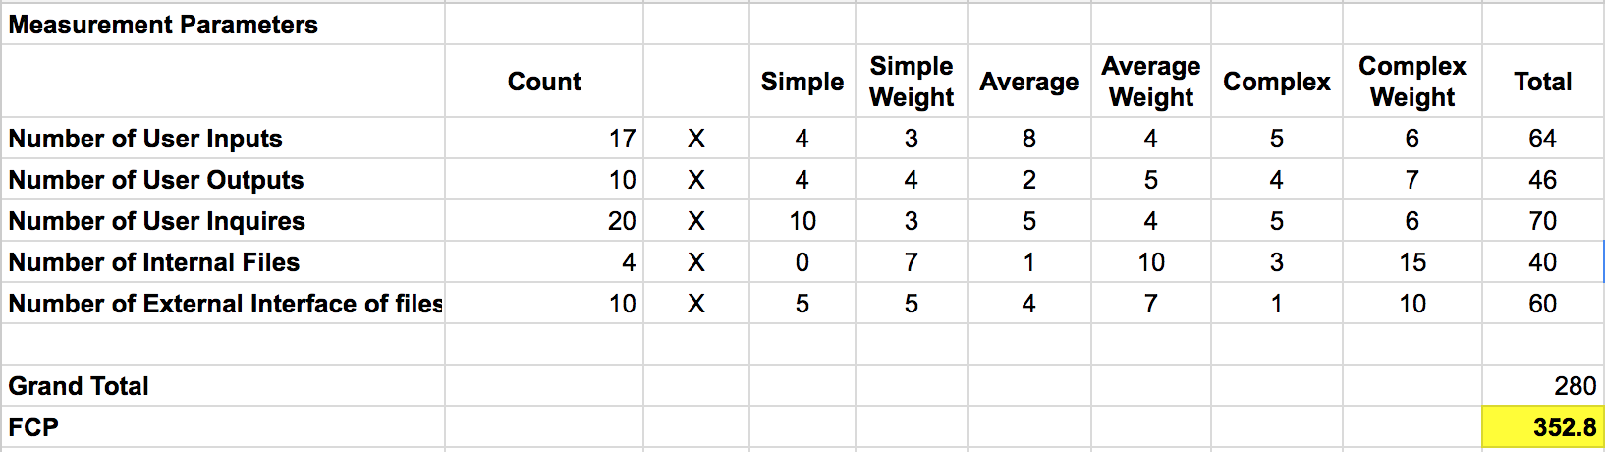

**Design of Objects (DOJ)**

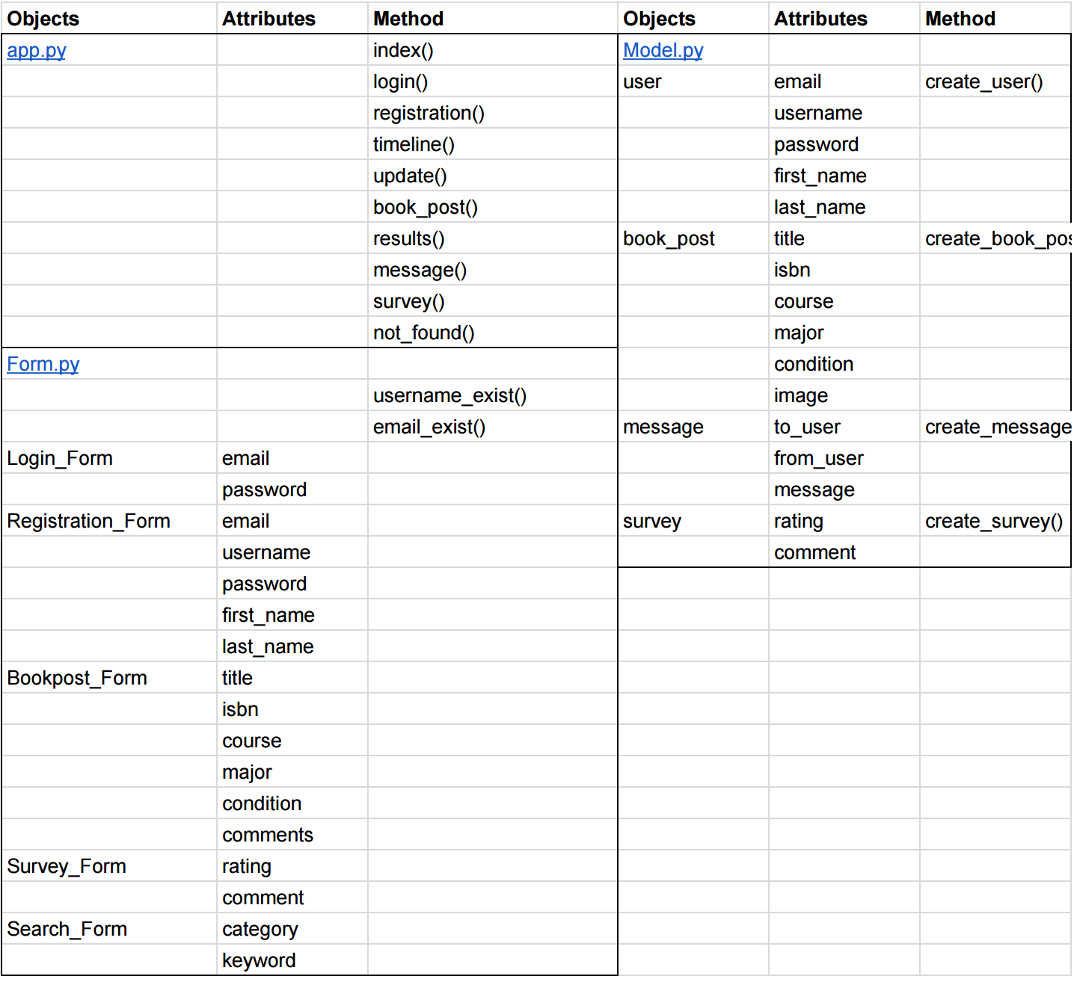

**Work Share Document (WSD)**

**Daniel Campbell**

Role: Front-End Programmer

**McKenzie Rochester**

Role: Back-End Programmer

**Jeff Sikala**

Role: Database Programmer

**Jordan Smith**

Role: Technical Writer

**Anthony Jones**

Role: Team Leader/Client/Tester

**Project Timeline (Gantt Chart)**

October 16, 2016

|  |  |  |  |  |
| --- | --- | --- | --- | --- |
| Task | Task Description | Duration (Days) | Start Date | End Date |
| Introduction | | | | |
| 1 | Team Creation | 3 | 23-Aug | 25-Aug |
| 2 | Identify Team Roles | 3 | 25-Aug | 27-Aug |
| 3 | Identify Project Idea | 4 | 27-Aug | 1-Sept |
| 4 | Work Sign Document (WSD) | 5 | 28-Aug | 1-Sept |
| Requirement Elicitation | | | | |
| 5 | Problem Statement | 3 | 13-Sept | 17-Sept |
| 6 | Requirements Trace Matrix (RTM) | 2 | 17-Sept | 18-Sept |
| 7 | Gantt Chart | 2 | 17-Sept | 18-Sept |
| 8 | Dictionary | 2 | 17-Sept | 18-Sept |
| 9 | Project Rational | 2 | 17-Sept | 18-Sept |
| System Analysis | | | | |
| 10 | Updated Problem Statement | 3 | 19-Sept | 21-Sept |
| 11 | Update RTM, Gantt Chart, Dictionary | 3 | 22-Sept | 24-Sept |
| 12 | Use Cases | 9 | 24-Sept | 2-Oct |
| 13 | Interaction Diagrams | 1 | 2-Oct | 2-Oct |
| 15 | Horizontal Prototype | 1 | 2-Oct | 2-Oct |
| Object Design | | | | |
| 16 | Object Design | 2 | 12-Oct | 14-Oct |
| 17 | Function Point Cost Analysis | 1 | 15-Oct | 16-Oct |
| 18 | Update Gantt Chart | 1 | 15-Oct | 16-Oct |

**Dictionary**

* Web Application: A client server software application in which the client runs in a web browser.
* Database: A location where data is stored. It uses a language called SQL to issue commands to it. In our project we will be using SQLite as our database.
* URL: Uniform Resource Locator. Provides an address to a location on the world wide web.
* Redirected: Takes a user from one website to another website typically through a hyperlink.
* Query: A command for SQL databases.
* App: Short for application.
* Web Browser: A software application for retrieving, presenting, and traversing informational resources on the world wide web.
* Course: A class that is offered by a university or college.
* Web Browser Credentials: Information that is temporarily stored within the web browser in order to keep a user logged into the system for a period of time.
* Model: handles the database portion of the application. Also adds functionality to any objects.

**Object Rational**

**App.py** - the App.py object gathers input from the user and makes changes to the database and the display of the app.

**Form.py** - parent class for the various forms on the website

**Login_Form** - user writes in information and it is then put into the database

**Registration_Form** - user input information necessary for profile creation and the database is updated with the new information

**Bookpost_form** - user input information necessary for posting a book on the website and the database is updated with new information

**Survey_form** - ratings and comments form for the buyer’s experience with the seller

**Search_form** - form for user input to allow searches for different books

**Model.py** - parent class for the various model’s for the app.

**User** - handles creating and storing the user model to the database.

**Book_post** - handles creating and storing the book post to the database.

**Message** - handles creating and storing messages to the database.

**Survey** - handles creating and storing surveys to the database.